NOC

Internship acceptance letter

Internship finishing letter

Daily diary

Attendance report

About the company:

Brief:

Projects and vision mission:

Team I will be working under:

Role of the team

Internship structure/guidelines:

Training phase:

Week1

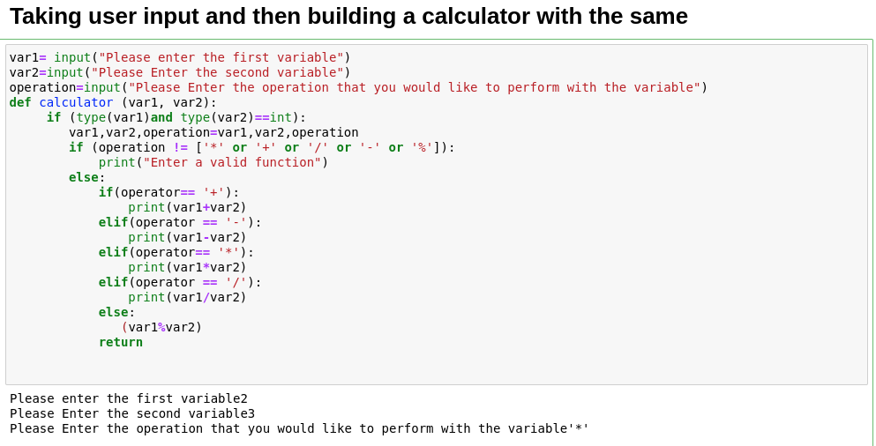

Week2

Python

Week3

Python and aws

Week4

Aws and docker

Week5

Aws and git

Week6

linux

Week 7

(live project)

About the project

Why do we need the project

Some recent scandals

Some techniques

About the live project

Brief of the project

Week 8

Approaches to the architecture;

The s3 data lake and one another

Week 9

Project Architecture

Proposed solution: Aurora, dynamodb, snowflake

Solutions diagram

Tech Stack

Week 10

Week 11

Week 12

Challenges

Advantages of the projects

Disadvantages

Further notices?